Milestone 1

WEB601

Daniel Musgrave

2019

# Introduction

# Site Goals

## Mission and Purpose

The purpose of this site is to create a centralized hub for all of the various services that I can provide people, acting as both a portfolio and a means of organizing potential hired work.

## Goals

## Target Audience

## Incentive

# User Experience

## Audience

## Scenarios

## Competitive Analysis

# Site Content

## Content

## Requirements

## Groups and Labels

# Site Structure

## Metaphor Exploration

## Site Structure Listing

## Architectural Blueprints

# Visual Design

## Wireframes

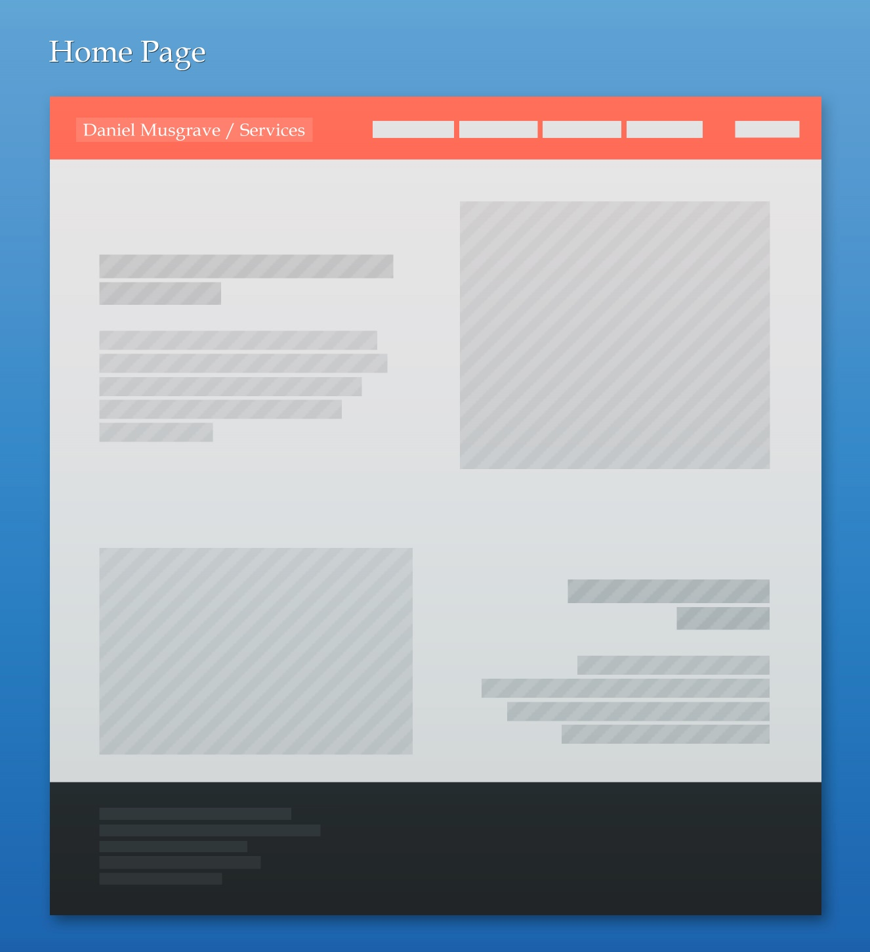

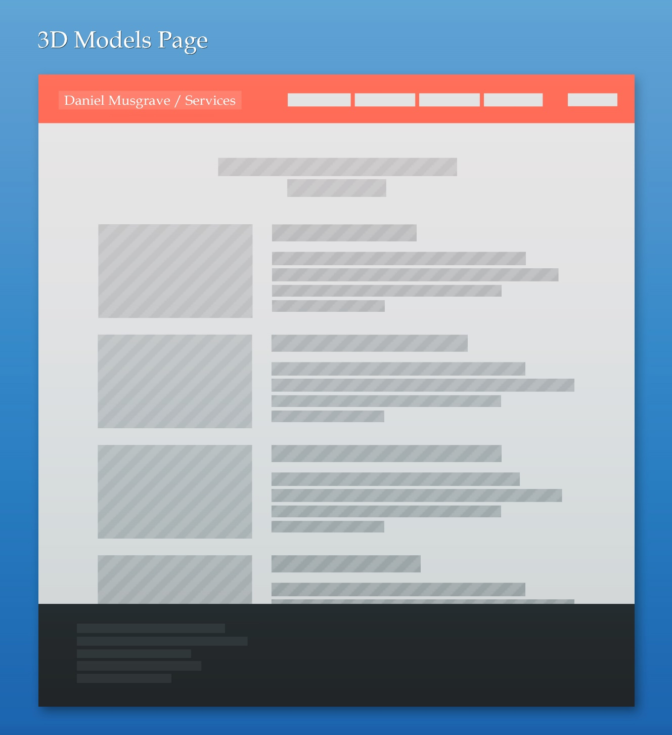

## 

## Sketches/Mockups